- Screen: IPD Doctor
- IPD Doctor should not be able to see anything except for IPD Patient details that he has ever consulted or is assigned to consult. This should be the landing page and Dashboard for IPD doctors.
- In case a doctor is both IPD plus OPD – he should be able to see only his patients in both department that he has ever consulted or has an appointment for consultation in the future for both the department (IPD/OPD)
- In case a doctor is across all departments IPD,OPD and Emergency – he would be able to see only his patients across all three
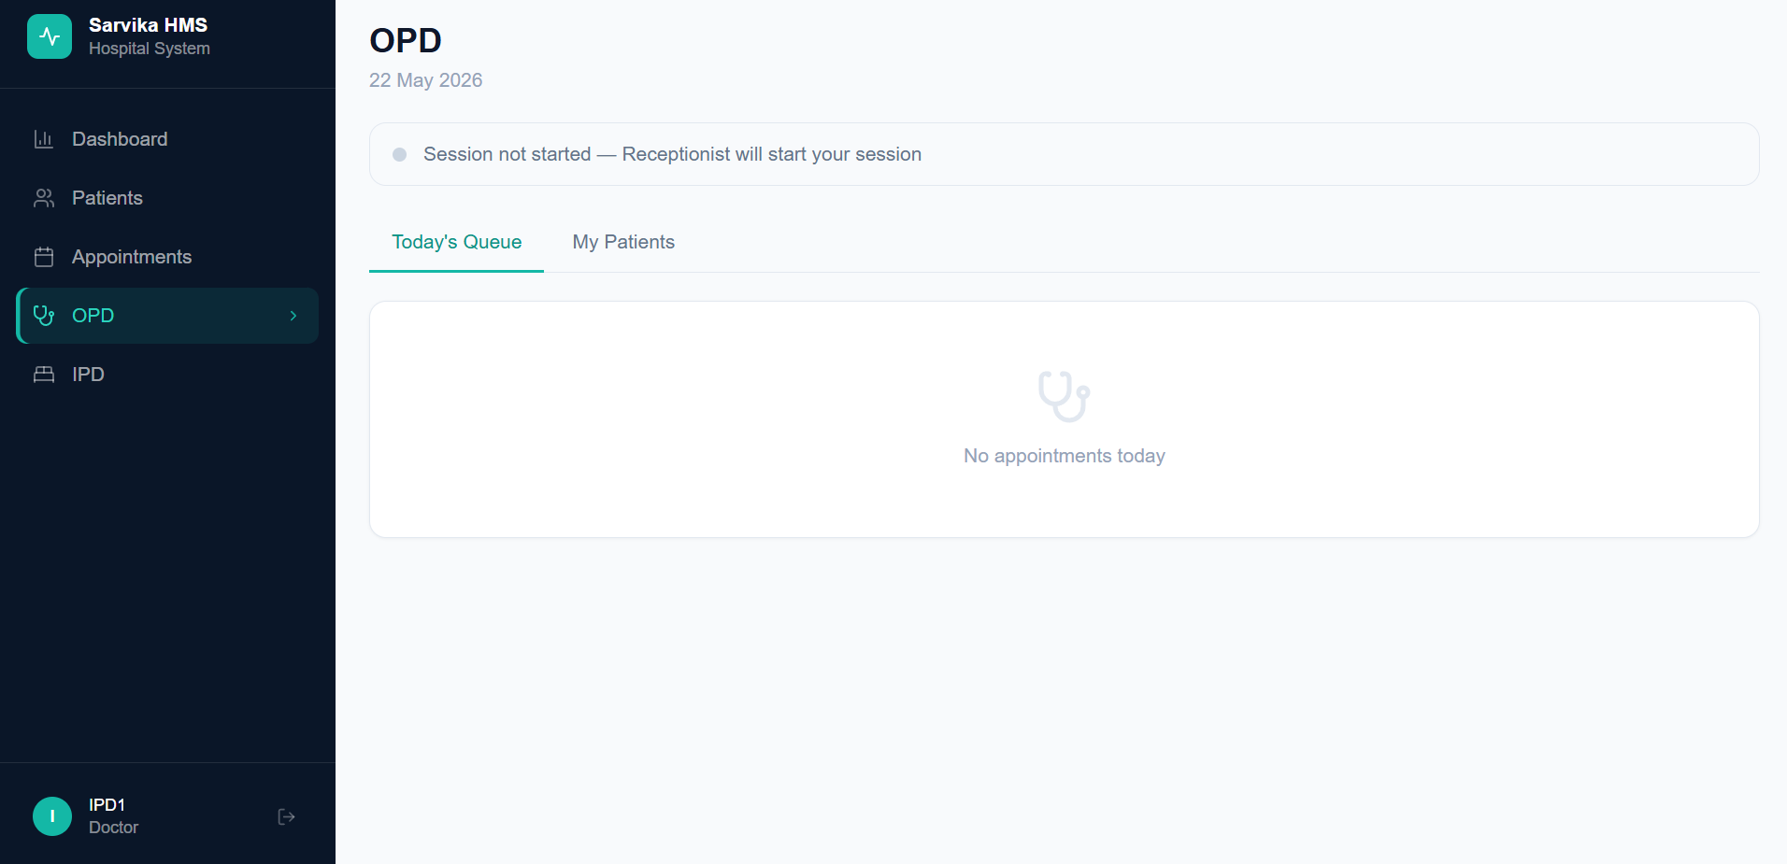
- For IPD doctors – there should be an option for the doctor to write prescription against his assigned patient. (Please note: this “write prescription” option against IPD patients will only be visible to IPD doctor(s) who is/are consulting that particular patient)
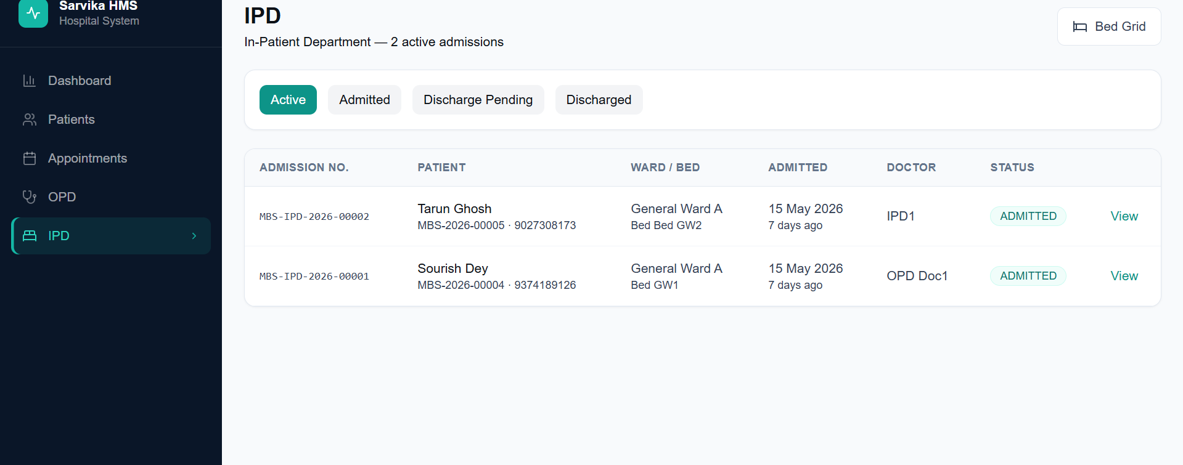

- Screen: Cashier
- Upon logging in on Cashier screen – the landing page is billing page – which is correct. But in the billing page “All” filter is not showing ongoing bills active for admitted IPD patients (refer to below screenshot). Whereas we can see the same upon clicking “IPD” filter in the page (attached screenshot)
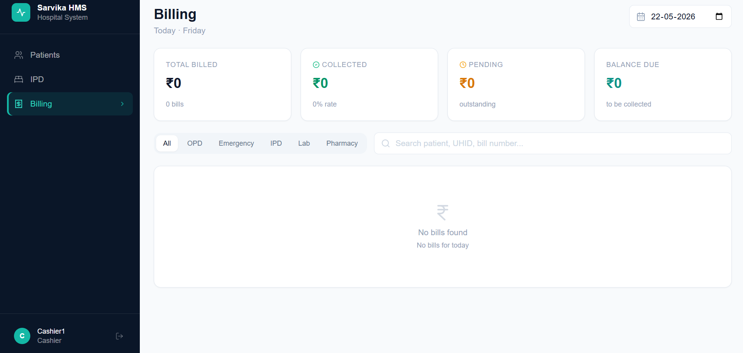
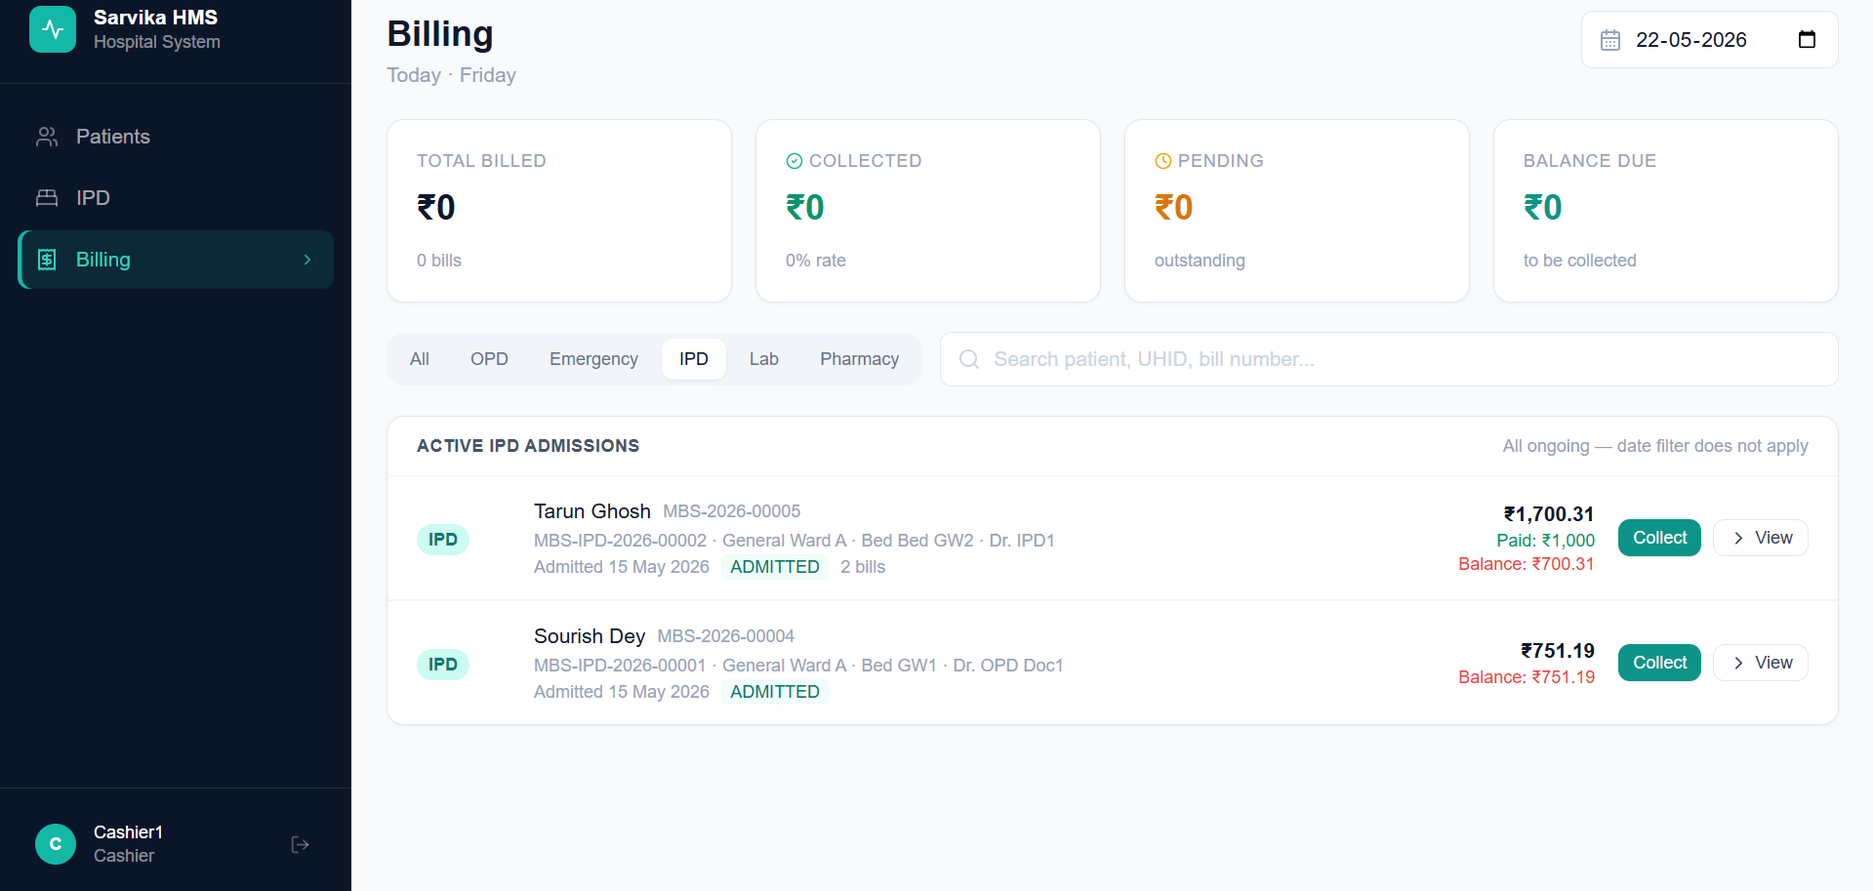

- There is a major change in the workflow of the Hospital –
- Receptionist to generate bill and collect payment for OPD patients only
- In case of IPD – receptionist will only be able to admit patient and only the cashier has the option to initiate discharge of any admitted patient upon complete bill settlement
- Once a patient is admitted in IPD – a ongoing bill is generated (as it is currently there in the tool) – but this receptionist should not be able to add/modify anything on this ongoing IPD bills
- Only Nurse and Cashier can add something to an ongoing IPD bill and can modify any previously added item only upon admin approval
- The ongoing bills are to be visible to the cashier.
- Once a patient is to be discharged – the cashier after collecting all dues should click on “Dues Cleared and Initiate Discharge”. The total bill and the patient summary of admission including prescriptions should be able to be either printed or sent on whatsapp

